**Group 8 Self Introductions**



***Paninchaya Sawasdinavin (Prya) 6848026124***

Hi! My name is Paninchaya Sawasdinavin, but you can call me Prya (pre-ya). I am currently 16 years old, and I went to

Raffles American School. I did the GED and applied to PGS early because I felt I wanted to explore a new environment, and decided this was the place for me.

I chose PGS as I felt it was the most suitable pre-law course for me as I am aspiring to be a corporate lawyer. I am also currently doing a bachelors in law at Ramkamhaeng University to help me with that journey.

With the double degree program, I saw it as a win-win situation. I have always loved Chula, and the idea of being able to pursue a degree here as well as exploring abroad all by myself seemed like a dream come true. I first had an interest in law when I was four, but also had a few other aspirations along the way before finally landing on law as a concrete choice because I felt it was something I genuinely enjoyed. Throughout my life, I felt I didn’t have much of a voice or freedom, so I decided to study law in hopes to give other people a voice as well.

As of currently, I am leaning towards the UQ track of PGS, as I feel it suits my interests more and will help me get into law school as well since I am considering law schools in Australia as some of my options.



Apipu Suphapetiporn

Hey, my name is Apipu Suphapetiporn and I am a 19 years old student. In 2025 I graduated from EIS and applied for the Politics and Global Studies Program. I picked this program because I wanted to learn more about politics and create change.

I also felt like going abroad would give me different ideas about politics that I can use in the future. I also explored my other interests such as law and philosophy when I was in high school by starting a law and criminology club and being the vice president of philosophy club. I also explored by interest in Model UN by delegating in a small number of conferences and being the Vice President of the MUN club.

If possible I would like to spend my time abroad at Leeds, because the university is famous for its academic standards and quality professors. I hope they will be able to provide me with a good experience as well as world class knowledge. I hope to go to graduate school afterwards to further my knowledge in public policy and hopefully use it to solve many issues people face.

—————————————————————————————————



Tinn Chandra (Tintin)

My name’s Tinn and I chose PGS because I wouldn’t shut up about politics and I suck at maths. I also genuinely want to create positive change and I believe that PGS will help me achieve that goal.

I have many interests including fencing, abstract painting, cooking, music, history and photoshop (as you can see from the above picture). I also own a small food business that sells premium beef stew online. I believe that our cities and towns can be designed more beautifully and efficiently, and that by doing so, people’s lives will substantially improve. I also believe that political science degrees will be more and more valuable to the job market in the future, as investors and international companies need people to guide them through the fog that is global politics. I am excited for this class and I am glad to know all of you.

**Padhabhop Khoomcin**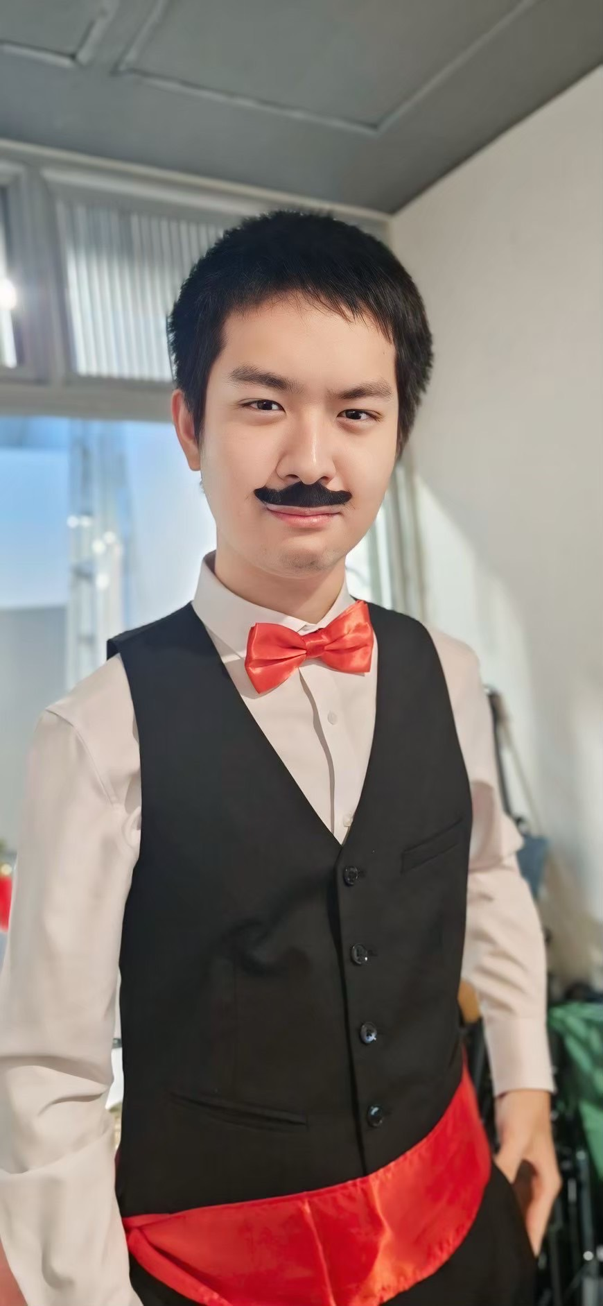

Hello, my name is Padhabhop Khoomcin, but you can call me Vino. I am 18 years old, and I graduated from the Kasetsart University Laboratory School, Center for Educational Research and Development. I applied to PGS because I am interested in politics and want to make real change to the country, whether it be to establish good connections with other countries, or participating in local politics to improve the community.

My fascination with political science stems from a deep curiosity about governance and the interconnected nature of global systems. I am particularly drawn to the historical development and impact of Western political systems on global governance and international relations. As I strive to comprehend and contribute to this field, Chulalongkorn University’s International Program in Political and Global Studies appeals to me, offering a diverse approach and a global perspective.

I am eager to explore contemporary issues within Western political systems, such as political conflicts, climate policies, and the role of Western nations in international diplomacy. I also aim to study how Western political ideologies have both influenced and been influenced by global events. Chulalongkorn University’s multidisciplinary curriculum and international perspective provide the ideal setting to pursue these interests. Courses like Peace and Conflict Transformation and Security and World Politics align with my aspiration to understand Western strategies in conflicts within an interconnected world.